NAME: S. DHARANI
REG NO: 192472364
COURSE CODE: DSA0401
NUMPY / PANDAS ANALYSIS – QUESTIONS AND ANSWERS
QUESTION 7: CUSTOMER ORDER ANALYSIS USING PANDAS
AIM:
To find the number of orders made by each customer, average order quantity for each product, and earliest and latest order dates.
ALGORITHM:
1. Import Pandas.
2. Create the order DataFrame.
3. Group by customer ID and count orders.
4. Group by product and calculate average quantity.
5. Find minimum and maximum order dates.
CODE:
import pandas as pd
order_data = pd.DataFrame({
"Customer_ID": [1, 2, 1, 3, 2],
"Order_Date": ["2026-01-05", "2026-01-06", "2026-01-08", "2026-01-10", "2026-01-12"],
"Product": ["Pen", "Book", "Pen", "Pencil", "Book"],
"Quantity": [2, 3, 4, 5, 1]
})
order_data["Order_Date"] = pd.to_datetime(order_data["Order_Date"])
print("Orders per customer:")
print(order_data.groupby("Customer_ID").size())
print("Average quantity per product:")
print(order_data.groupby("Product")["Quantity"].mean())
print("Earliest:", order_data["Order_Date"].min())
print("Latest:", order_data["Order_Date"].max())
INPUT:
Five sample orders for customers 1, 2 and 3.
OUTPUT:
Orders per customer: 1 = 2, 2 = 2, 3 = 1
Average quantity: Book = 2.0, Pen = 3.0, Pencil = 5.0
Earliest: 2026-01-05
Latest: 2026-01-12
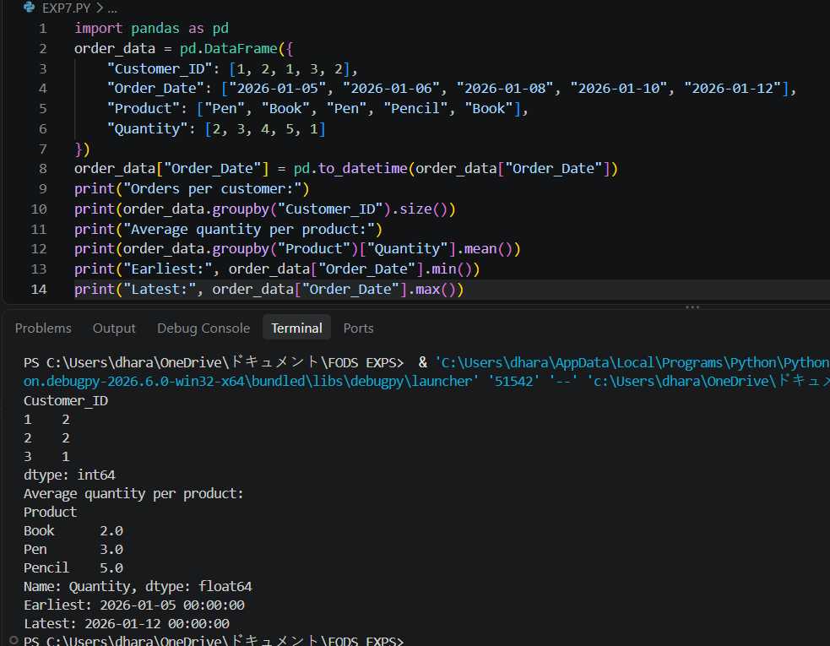
RESULT: Customer order counts, product averages and date range were obtained successfully.

